Introduction to Epi Info for Windows

Andrew G. Dean, MD, MPH
EpiInformatics
andy.dean_a_gmail.com
Where _a_ indicates “@”

Contents

Introduction to Epi Info for Windows 1
Contents 2
Getting Acquainted With Epi Info 3
The Epi Info Menu 3
The MakeView Program 6
Guided Tour of the Enter Program 15
Analysis 19
Epi Map 29
Nutritional Anthropometry with NutStat 33
Seeing Inside Databases with VisData 35
Comparing Data Tables to Validate Data Entry 36
File Encryption and Compression with EpiLock 37
Next Steps 37

Getting Acquainted With Epi Info | 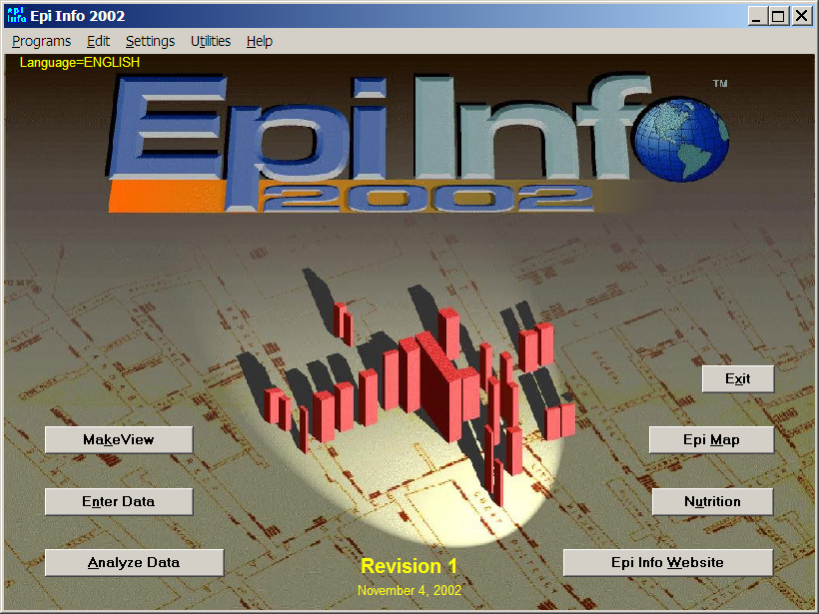
Epi Info (TM) is a series of programs for use by public health professionals in conducting outbreak investigations, managing databases for public health surveillance and other tasks, and general database and statistics applications
Epi Info (TM) software is in the public domain and freely available for use, copying, translation and distribution. It can be downloaded from www.cdc.gov/epiinfo/. The name, “Epi Info,” is a trademark of the Centers for Disease Control and Prevention (CDC), Atlanta, Georgia, USA.
This introduction provides step-by-step instructions for exercising the main features of each program. If you are reading from the screen, you may find it convenient to print the instructions using the PRINT command on the FILE menu of your browser or word processor. On a large screen, it is also possible to keep the instructions open in one window and work with Epi Info elsewhere on the same screen.
The Epi Info Menu | 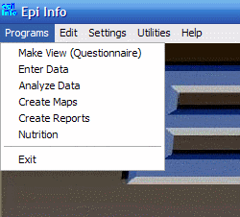
To run the Epi Info menu, double click its icon on the Windows® desktop or run Epi Info from the All Programs feature of the Windows START menu. The screen image for the main menu of Epi Info is John Snow's famous map of the location of cholera cases surrounding the Broad Street pump in London in 1854. Artistic license has been taken in representing cases near the pump as vertical solids rather than with Dr. Snow's neat tick marks.
The main programs of Epi Info can be accessed either through the PROGRAMS dropdown or by clicking on the buttons. MakeView is used to design a questionnaire or View. Epi Info automatically constructs a data table from the View so that data can be entered in the Enter program. Analysis is the data management and statistics program that reads any of 20 file formats, performs user-determined manipulations of the data, and produces tables, epidemiologic statistics, and graphs. Epi Map links geographically related data to maps, either from the desktop or from Analysis.
On the EDIT menu, alternative pictures can be chosen from the PICTURE item. The SETTINGS menu provides for installation and choice of non English language translations of Epi Info, and a setting to determine whether new database files will be created in Microsoft Access 97 or Microsoft Access 2000/2002 format. Epi Info will read files in either format automatically, but needs to have a preference set for creating new files.
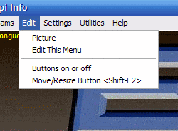 | 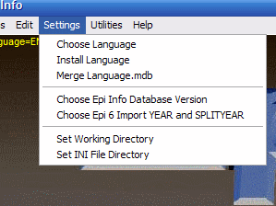
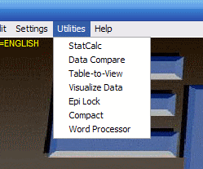 | 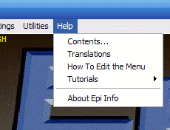

Menu items under UTILITIES include the StatCalc epidemiologic calculator, and new programs for comparing (validating) data in two different tables and for encryption (EpiLock). Table-to-View produces a questionnaire View from a Microsoft Access data table, and Visualize Data allows access to the inner details of database files for expert users.
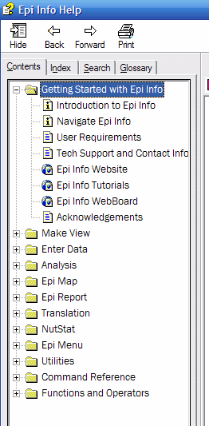
The HELP menu contains the entire manual and help file rather modestly listed as CONTENTS. Tutorials include three interactive exercises in epidemiologic computing. The Epi Info Exercises are the basis of a week-long advanced course in Epi Info use. They are best used as printed material. What’s New describes features introduced in the most recent Epi Info for those already familiar with Epi Info. A README.TXT file downloadable from the CDC website provides further information about recent improvements.
To gain confidence and to see that your system is functioning well, you might click on each of the buttons on the main menu and briefly examine the program that appears. After you run a program, return to the menu by the Exit button, the small “x” box in the upper right corner, or EXIT in the FILE menu. We will visit each program again in more detail, as described below.

Details of the Menu (MNU) File
If you are interested in the details of the file behind the menu, use the word processor and OPEN file EPIINFO.MNU. This text file is responsible for both the appearance and the function of the menu. Other MNU files can be created to develop menus to provide easy access to any Windows or DOS programs.

Concept | The change from DOS to Windows versions of Epi Info provides more than just prettier screens. Industry standards used in Epi Info for Windows provide for compatibility and interchange with other Windows programs. Data storage is in Microsoft Access format, and Analysis reads and writes 20 other data formats. Output is in HTML, the standard format of web pages.

The MakeView Program | 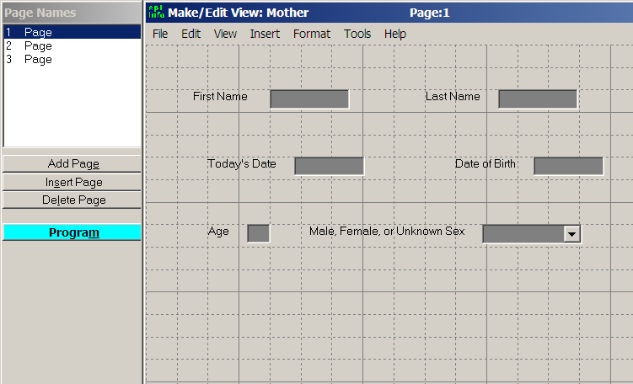

Concept | A Microsoft Access database or Epi Info project is a file that contains multiple tables. An Epi Info questionnaire is stored in a View table, and Epi Info automatically creates a Data table for storing entries.

Designing A Questionnaire View
To run MakeView, click on the MakeView button on the main menu screen. You should see a blank page for constructing a “View.” Questionnaires are called Views in Epi Info because there can be more than one View of a database or data table. A database table with the prefix “view” stores the screen appearance of the questionnaire, the characteristics of the fields, and any Check code that gives special instructions for the data entry process. Data values entered in the Enter program are stored in another table, the Data table, without a special prefix.
To make a view, from the FILE menu choose NEW…. The dialog CREATE OR OPEN PROJECT appears. Enter a name for your project database, such as your name or initials, and click OPEN.
A project or database (.MDB for "Microsoft Database") file can hold as many Views and data tables as you wish (well, up to 1000, anyway). Generally it is best to create a new MDB file for each project you develop, as an MDB containing hundreds of tables will be hard to copy to diskettes. Analysis programs for processing the data can be stored in the same MDB with the data, making a convenient project package.
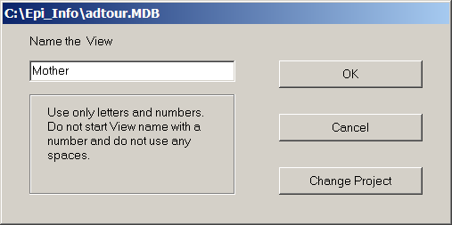
In the "Name the View" dialog, enter MOTHER as the name of the View within the MDB, and then click OK. Place the cursor near the upper left corner of the blank page and click the right mouse button. The field dialog box that appears offers options for entering the prompt, the field type and length, and a number of the characteristics that were previously implemented in Check files.
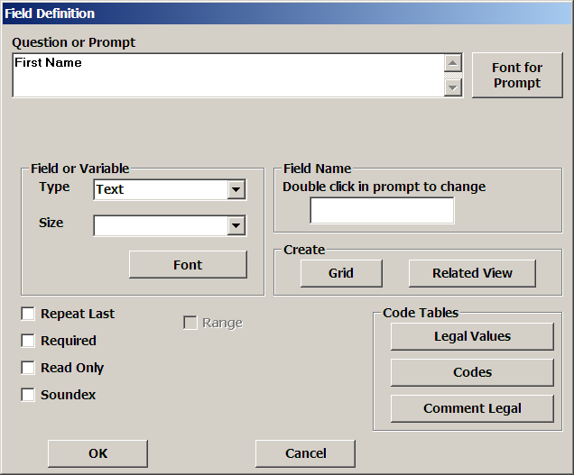
For the first field, enter the prompt “First Name” (without the quotation marks) and press Enter twice. This makes a text field that can hold up to 255 characters.
Concept | A Field is a place on the screen for entering data. It usually has a question or prompt and one of various types of entry blanks. The Field Name is the same as the name of the variable or column in a separate data table that stores the data.
For the next field, you could move the cursor and right-click with the mouse on a suitable location, but, to see a shortcut method, press Enter instead while the cursor is in the FIRST NAME field. The field dialog pops up again and you are ready to enter “Last Name” as the prompt. After doing so, press Enter twice, and note that the second field is now automatically positioned on the View.
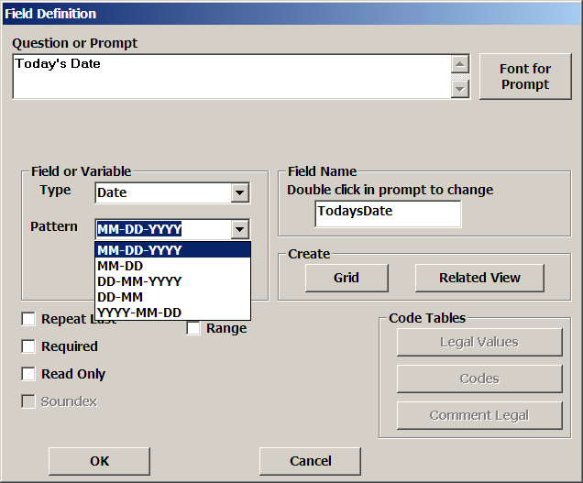
Below First Name, right-click to add another field. Enter the prompt “Today’s Date,” and use the scroll bar to the right of the field types to see the rest of the list of types. Choose the DATE type and the appropriate date format as MM-DD-YYYY or DD-MM-YYYY in the dialog. Click OK. Add another field for “Date of Birth,” using the same field type and pattern. Click OK.
Right-click on the form to make a field for AGE. Type “Age” as the prompt. Choose NUMBER for the TYPE and then choose ### or ## from the PATTERN list. You can also type patterns into the pattern window. Click on OK at the bottom of the dialog.
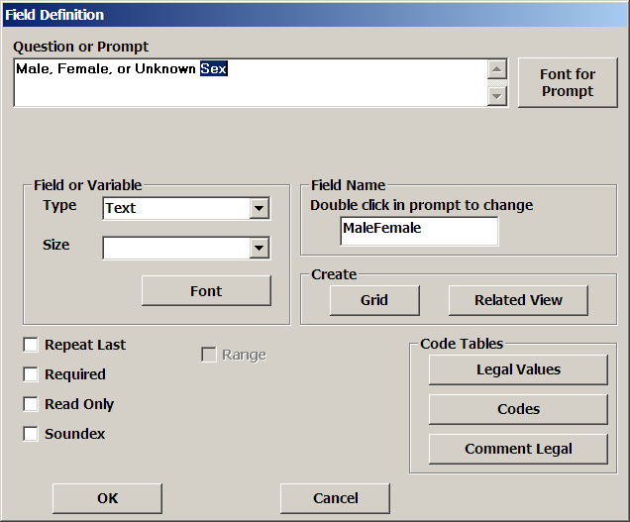
The next field is “Sex.” We will use it to illustrate how variable names are constructed. Right-click where you would like to place the field. Type “Male, Female, or Unknown Sex” in the prompt window, press Enter, and note what appears in the Field Name window on the right. Now click again in the prompt window, and with the left mouse button held down, select just the word “Sex”. Double-click on the selected word, “Sex,” in the prompt window. Note that the variable name becomes SEX. (In Epi Info 6, we would have enclosed “Sex” in curly brackets.)

Specifying A List Of Legal Values
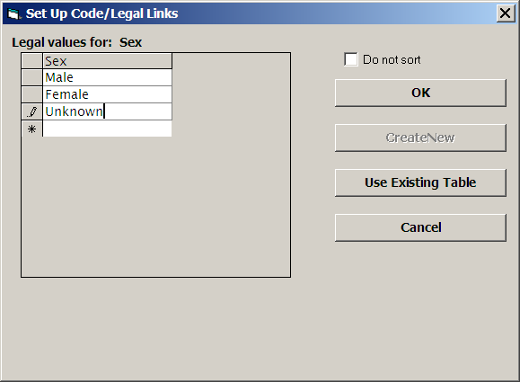
Now create legal values for SEX by clicking the LEGAL VALUES button. In the dialog box that appears, choose CREATE NEW, and then enter suitable values (Male, Female, Unknown) in the list that appears, pressing Enter after each to obtain a new blank line. Click OK, and then OK again in the field dialog box. Note the button on the right side of the SEX field. Left-click on the button to show the list of legal values from which to select during data entry.
To move a field on the screen, click on the prompt for the field and drag it to a new location while holding the left mouse button down. Use this method to space the fields on the page. Most types of fields can be resized by clicking in the field and then clicking and dragging the colored “handles” that appear. Text fields are limited to one line, but we will add a multiline field later.
Let’s group the fields together for esthetic reasons and to make them easier to move. To do this, first select the fields on this page by left clicking in the upper left corner and dragging the dotted rectangle that appears until it includes all the fields (or just a few). Now go to the Insert menu and choose Group. Give the group the name “Demographics,”and click OK. If you hold down the left mouse button over the word Demographics, you will be able to move the entire group and its contained fields as a unit.

The first page should look like this:
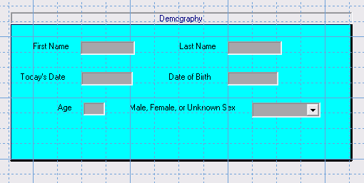

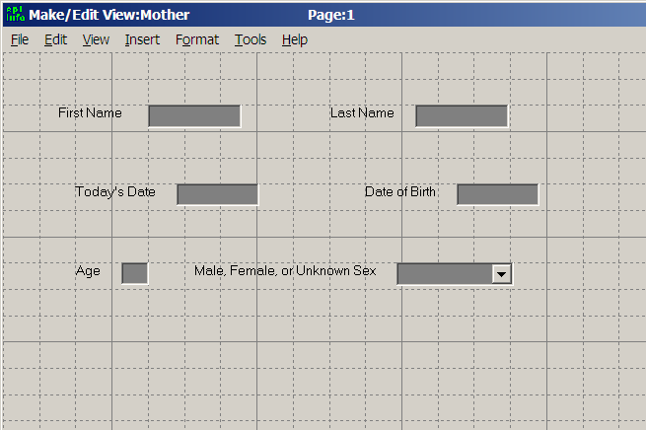
It is time to save the page and add another one. Click on the ADD PAGE button under the page window on the left side of the screen. The first page is saved automatically and a blank page appears.

Inserting A Grid To Deal With Repeating Data Within A Questionnaire
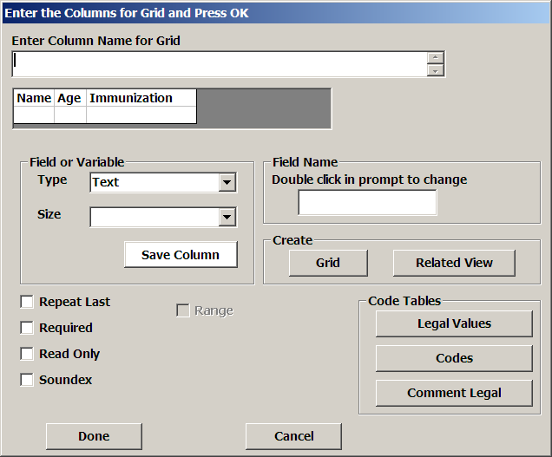
We are going to insert a Grid (table of columns and rows) on Page 2 to record the names, ages, and immunization status of the children in the household. Right-click in the upper left corner of the form and enter “Children in the Household” as the prompt. Click on the GRID button in the dialog. Enter the name of the first grid column, “Name,” in the prompt box that now says, ENTER COLUMN NAME FOR GRID. Click on SAVE COLUMN about midway down the form (DONE at the bottom is now for the entire grid.). Enter the second column as “Age” and make it a NUMBER. Click SAVE COLUMN and enter the last column as a text field called “Immunization.” Now click SAVE COLUMN once more and then DONE at the bottom of the dialog. The grid will appear on the View.
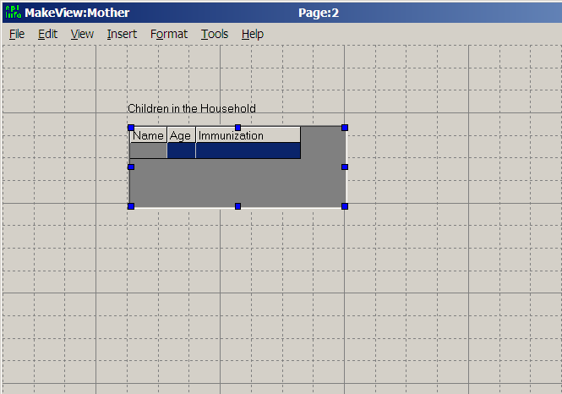
Click on the grid so that handles appear around it. Click and drag the lower right handle or others to adjust the size of the space for the grid. Click outside the grid to remove the handles. To adjust the size of the columns, hover the mouse over the line between two column headings until a right/left arrow appears. Then hold the left mouse button down and drag the line to the right or left to adjust the column width.
The grid will create a related file that will allow the user to enter as many children as needed for each household. The program automatically maintains an appropriate key for linking the related file.
Concept | Relational or hierarchical tables are an important way of dealing with data for a person with repeated visits or episodes, a household or parent with many children, etc. The “parent” and “child” records are linked by a UniqueKey identifier that is created automatically by Epi Info. Related tables are created by inserting a grid or by creating a related View using the RELATED VIEW button in the field dialog of MakeView.

Large text (multiline) fields
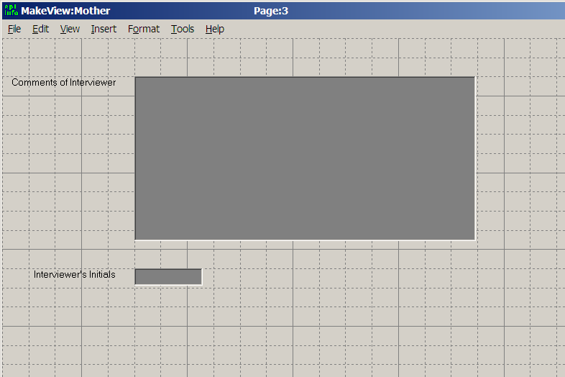
Click ADD PAGE again and you are ready to make page 3 of the View. Now make a field of the MULTILINE type having the prompt, “Comments of Interviewer.” Click OK and then click on the field, adjusting its size as you did with the grid to make it large enough to enter a number of comments. There is no practical limit on the amount of text that can be entered in MULTILINE fields. Add a text field for “Interviewer’s Initials,” and save this page with the SAVE command on the FILE menu. This completes the questionnaire view.

Making a Data Table from the View and Entering Data
Concept | A Data table in Epi Info is constructed automatically from information in the View table. Editing the View causes the structure of the table to be updated before the next data entry.
Still within MakeView, choose ENTER DATA from the FILE menu and respond “OK” to have the program construct a database from the view. The data table will have the name displayed (“Mother”), unless you choose to edit the name. When you click OK, the Enter program displays the view for data entry. Try entering first and last names, today’s date, and a date of birth, pressing the Enter or Tab key after each field. Note that the cursor moves on to the Age field and allows entry without performing any automatic calculations. Because we would like AGE to be calculated automatically after entering Today’s Date and a Date of Birth, we will return to the MakeView program and construct a small program to do the calculation and skip over AGE if the dates are entered.

Using Check Code to Program the Data Entry Process
Return to the MakeView program by choosing EDIT VIEW from the FILE menu. Bring up the Check Code environment by clicking the PROGRAM button on the left.
The Check Command panel appears at the top of the screen.
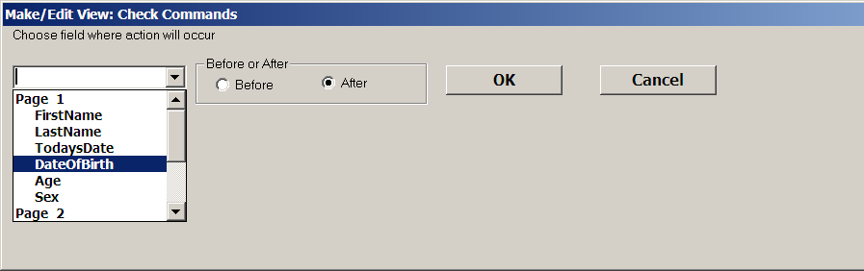
Below it is the program editor.
Click on the arrow under “Choose Field Where Action Will Occur” to pull down the choices. Since we want Age to be calculated after DateOfBirth is entered, choose the DateOfBirth field. In the tree of commands on the left side of the screen, click on the ASSIGN command. Display the list of available variables for the ASSIGN VARIABLE by clicking on the arrow. Choose AGE. Since it is not immediately clear how we should calculate the age from two dates, click on the FUNCTIONS button, and then choose YEARS from the list of functions in the help window. Information appears about the YEARS function, as follows:
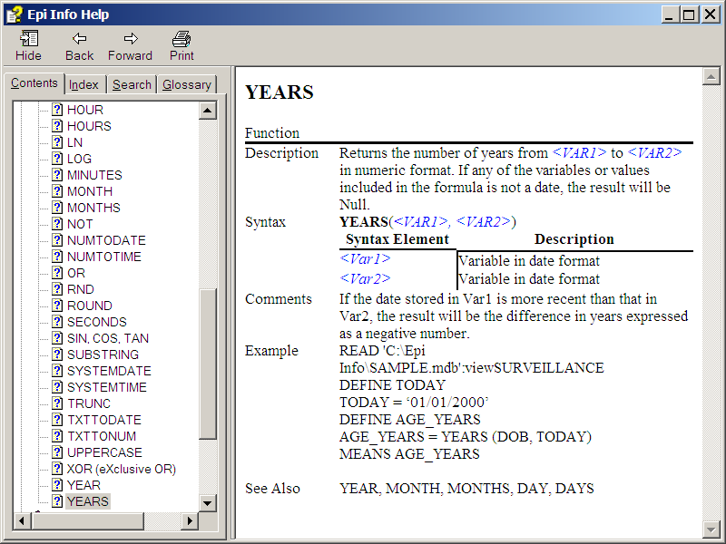
YEARS is a function that calculates the interval between two date fields in years rather than days, weeks, or months. The starting date is listed first and the ending date second in the parentheses, separated by a comma. A list of functions is contained in the Functions and Operators chapter of the manual.
The help window provides enough information so that we can type Years(DateOfBirth,TodaysDate) for Expression. Choose the field names from AVAILABLE VARIABLES if you do not know them in advance. Exact spellings are required, but upper and lower case are not important. Do not put a space after YEARS.
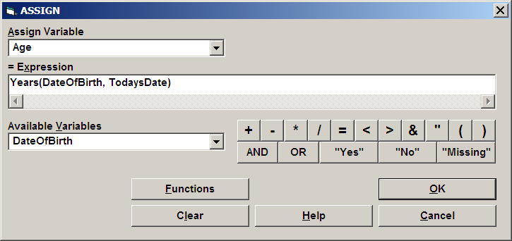
Click on the SAVE button and note that the command,
ASSIGN Age=Years(DateOfBirth, TodaysDate)
appears in the program editor.
Now from the Command tree, choose the IF command. In the IF CONDITION blank, type (or select from the pull-down list and the buttons) the condition, AGE>=0. In the window under the THEN button, type GOTO SEX. (If you click the THEN button instead, you will have access to the available commands, but only on the tabbed dialog, not in the command tree).
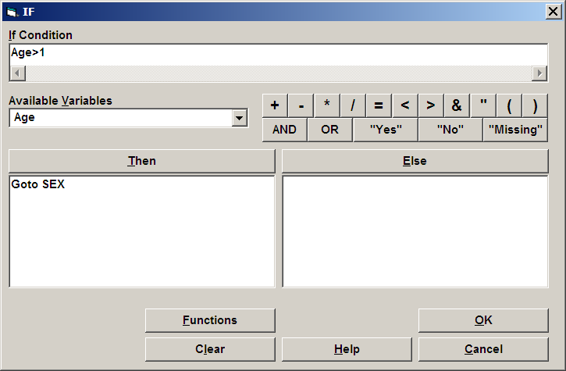

Click OK, and you should see in the program window, the commands:

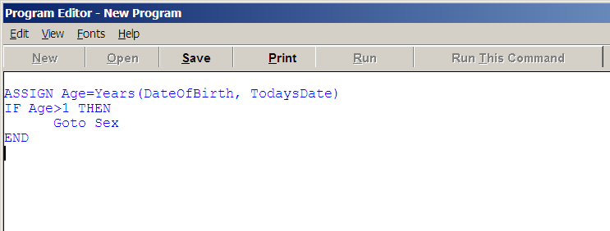
You have written your first Epi Info Check program. Exit from the Check programming facility by clicking on the OK button. This completes the view.
Concept | Check code in Epi Info spells out what should happen before or after the cursor enters a field during data entry. The Check Code for each field is stored in the View with that field. Complex conditions and actions can be specified to impose “business rules” on the data being entered, and minimize the amount of editing needed later.
Although you could exit from MakeView at this point and run the Enter program from the Epi Info menu, it is more convenient to run Enter from within MakeView so that you can return and make changes. Choose ENTER DATA from the FILE menu once again, and the program will return to Enter.

Guided Tour of the Enter Program | 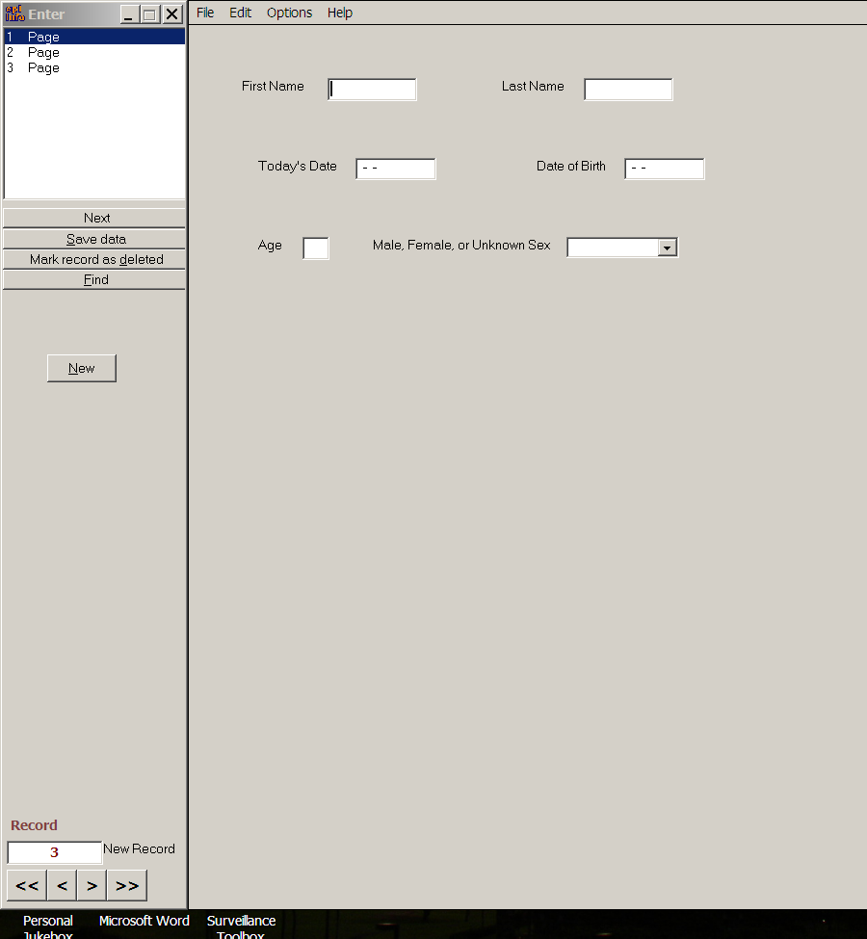

Entering data and verifying that your age calculation works
You should have the MOTHER questionnaire on the screen. If not, go back to the main menu and choose ENTER DATA, OPEN on the File menu, and then the database that you created and the MOTHER view. Enter data in the fields displayed. After you enter Date of Birth, the age should be calculated automatically, and the cursor should jump to the Sex field. At the end of each page, the entries will be saved automatically.
On page 2, fill in the grid with reasonable answers. After the first line, a second is created automatically. Enter as many children as desired, moving the cursor with the ENTER key and/or arrow keys. Press the Esc key to exit from the grid. Since there are no more fields on the page, the cursor moves to the next page, after saving the data in the current page.
After entering the data for page 3, press the Enter key. You can also click on the NEW button to save the current record and move to page 1 of a blank record. You should now see an empty record, ready for entry. Note that the record number appears at the lower left. To see previous records, click on the single back arrow button next to the record number. Be sure to enter at least three records, with at least two children in the grid for each, so that we can do analysis of the grid records along with the main questionnaire.

Opening Another View
To load another view containing more data, choose OPEN from the FILE menu and then click on CHANGE PROJECT. Choose the database SAMPLE and the View OSWEGO. Note the record number at the lower left is 76, representing the 75 records in the table plus the empty record now on the screen.
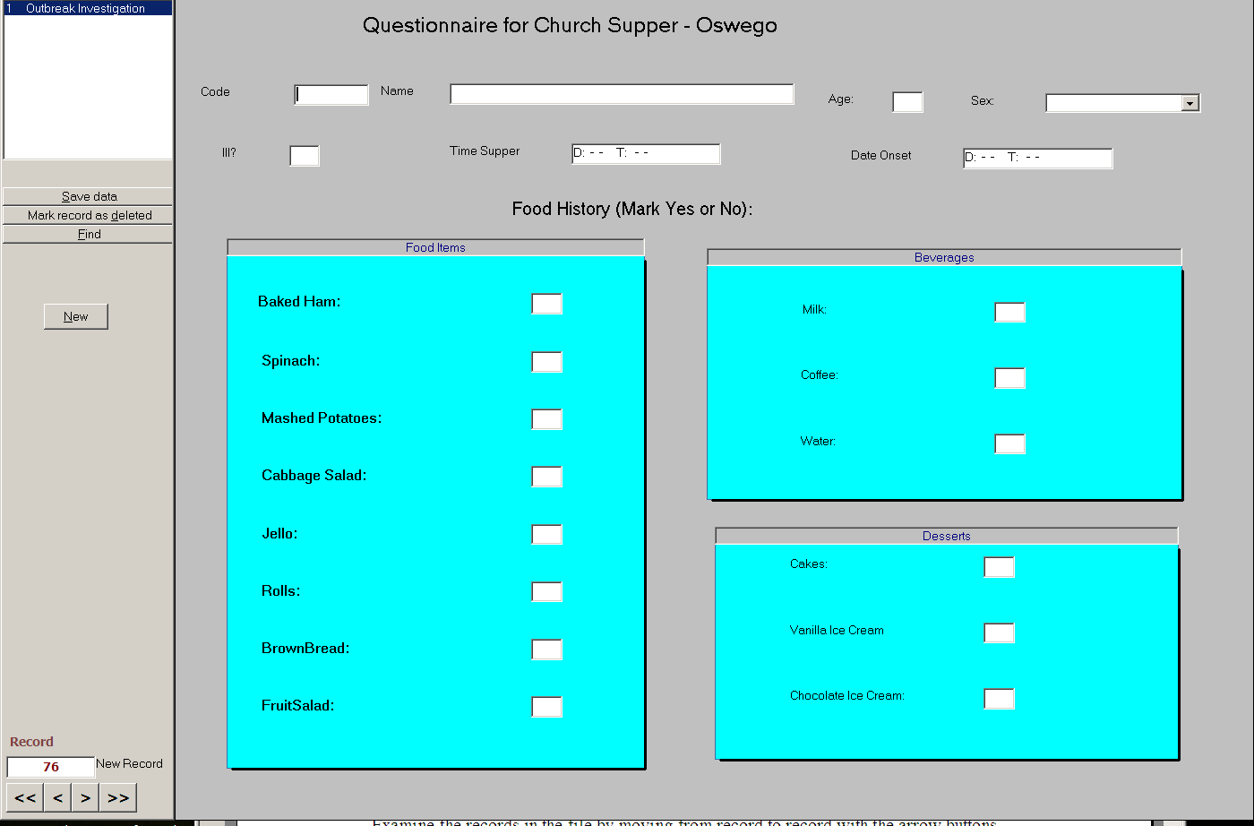

Moving From Record to Record
Examine the records in the file by moving from record to record with the arrow buttons on the lower left. The double arrows move to the first and last records; single arrows move one record at a time. To move to a new record, click on the double right arrows twice, or on the NEW button.

Finding Records
To find records matching specified criteria, click on the FIND button on the left. A dialog box appears. Choose the AGE field and then type “11” (without quotation marks) in the field that appears. Click on the OK button to find all the records in which AGE is 11. To choose one of these records for editing, double-click on the left side of its row until the entire row is highlighted and the selected record appears on the screen. If you prefer not to select one of the records shown, but to continue with the current record, click on the BACK button.
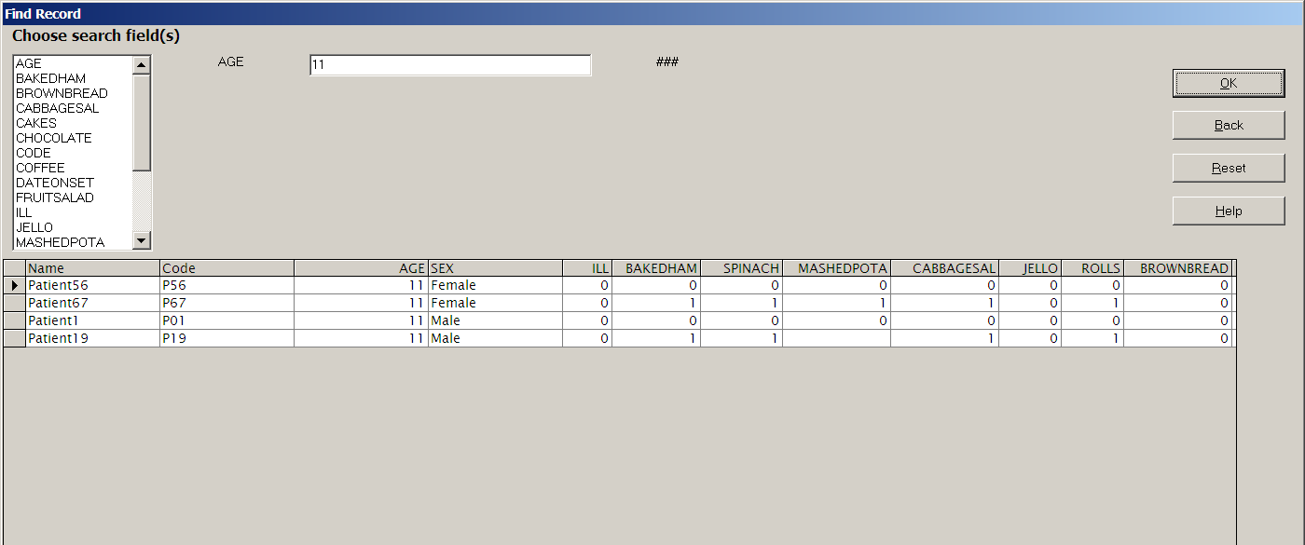

A More Complicated View with Groups of Variables and Related Views
Open the view called SURVEILLANCE in the SAMPLE.MDB database. Note that the variables are arranged in groups.
Related Views are shown as buttons on the questionnaire View, in this case, in the lower right corner. Because each of the Views shown is designed for a particular disease, they are inactive and do not respond to mouse clicks when you first open SURVEILLANCE and a new, blank record is displayed.
Use the double left arrow buttons in the lower left panel to move back to record 1. Note that the Disease in record 1 is “Hepatitis,” and that the HEPATITIS DETAILS button is therefore active. Click on this button to see the special form for Hepatitis. In this usage of related forms, only one record can be entered for the Hepatitis Details for a given case, but with other forms of related records (e.g., for children in a household), multiple records can be entered. Use the Back button to return to the main Surveillance form.

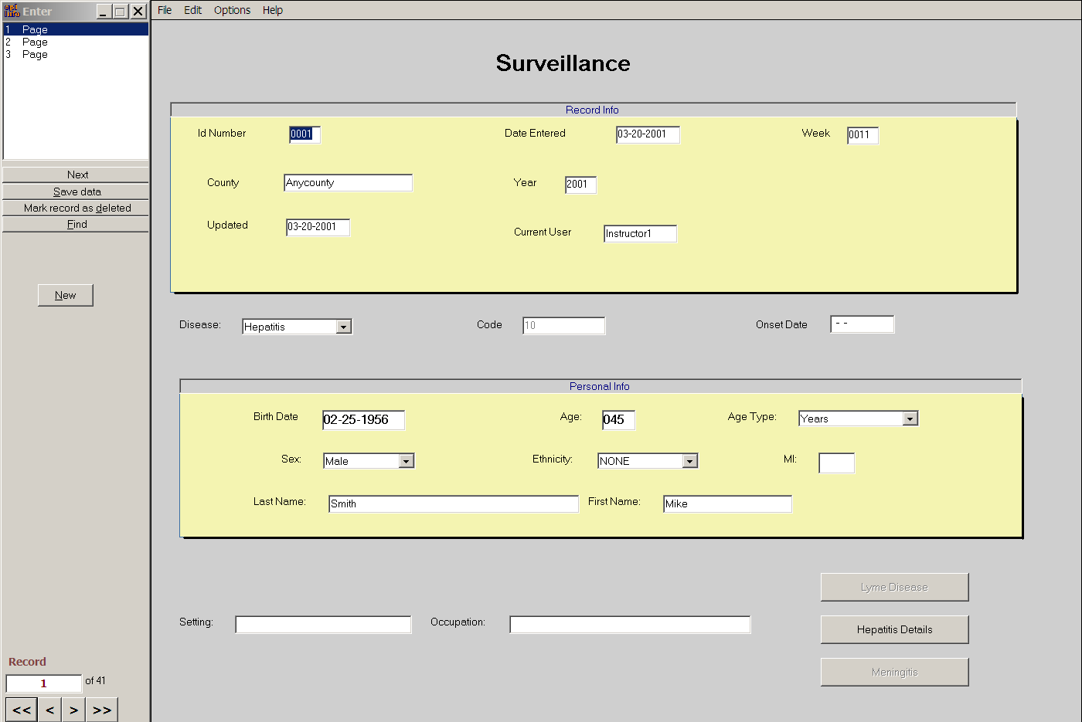
The related View, Hepatitis Details
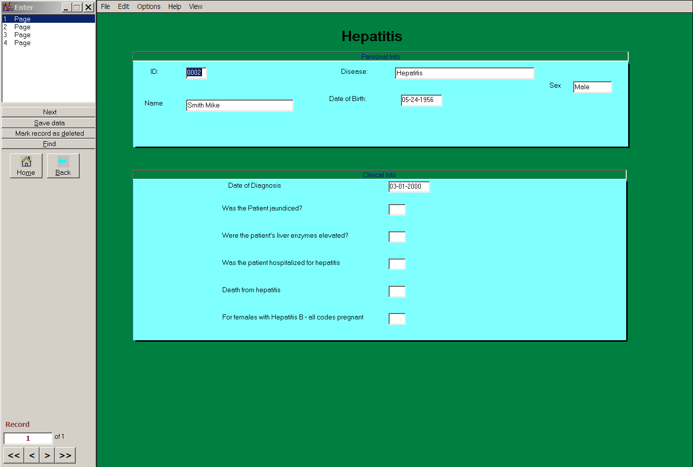
After experimenting with SURVEILLANCE and perhaps entering one or more records, choose EXIT from the FILE menu to return to the main menu.
Analysis | 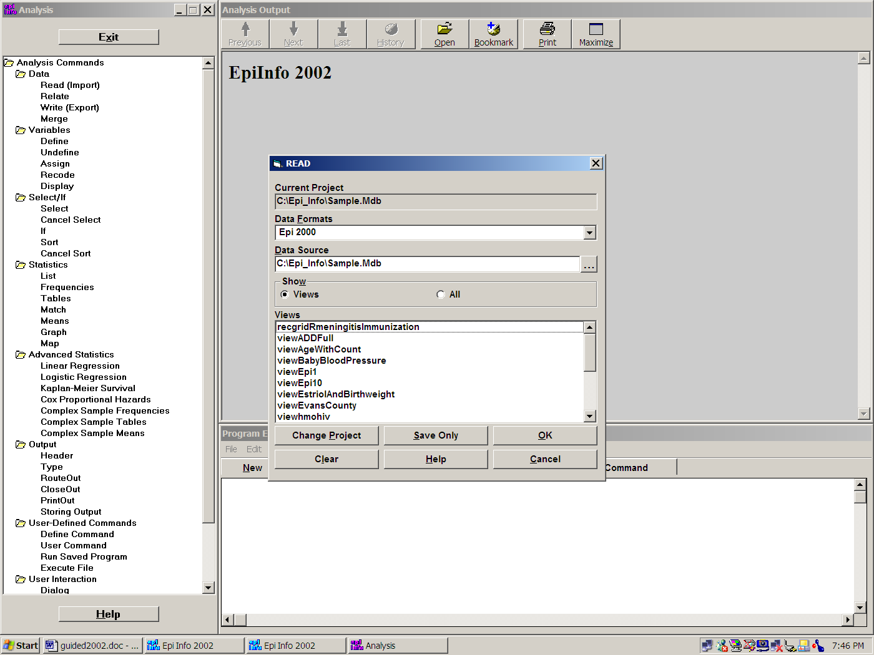

READ a view or a data file or table
To run Analysis, click the ANALYZE DATA button on the main menu screen. Note that all commands are shown in the tree view on the left. Clicking on a command will bring up a dialog that places the command in appropriate form in the program editor at the bottom of the screen. Results appear in the Output window, a simplified version of the Microsoft Internet browser.
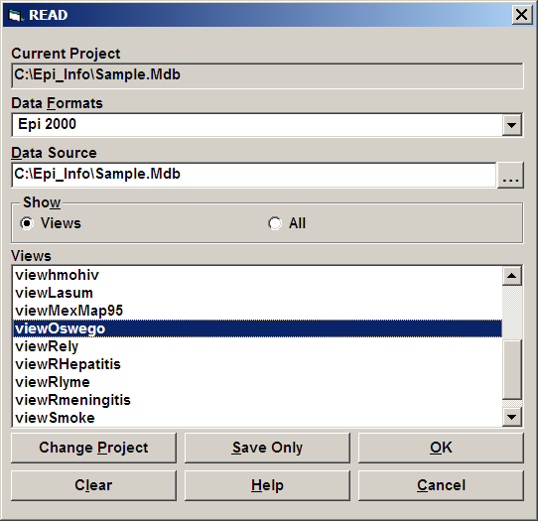

READing a View in Analysis
Click on the READ command. A dialog box appears so that you can choose a database and a view. Click the button called CHANGE PROJECT and then use the button with the three dots next to DATA SOURCE to find the MDB or Project that you created earlier, probably with your own initials. A view called viewMother should be present. Select this view and click OK. Note that the READ command appears in the program editor in the proper syntax. You are creating a program by responding to questions in the dialog boxes.

Seeing the Records
Click on LIST in the command tree. Select * for “ALL” and click OK to see the data you have entered. Note that the names, ages, and immunization status of the children is not shown, since it was entered in a Grid and has a separate data table.

Analyzing Data in a Grid
To see the children’s data, use the RELATE command. Choose the view called RecGridMotherChildrenIn or something similar, and click OK. The number of records increases, if you entered more than one child per mother. There now is a “record” for each child, linked to the mother by an internal UniqueKey number maintained by Epi Info. To see the records, use LIST again with * for “ALL”, and note that each child has data and that the mother’s data items are duplicated for each child. You can now analyze the data to find out how many children there are, and the ages of their mothers, for example. To avoid getting into relational file systems too deeply, however, we will leave this example and load up a straightforward dataset from an epidemic, the famous Oswego foodborne outbreak.

READing viewOswego
Click on the READ command once more and than on CHANGE PROJECT. Find SAMPLE.MDB in the Epi_Info directory, and then choose viewOSWEGO. It should have 75 records.

Lists
Click on the LIST command. In the dialog that appears, choose one or more variables or click on “ALL” to choose all. Choose GRID as the output format and click OK. The variables are displayed in columns in a scrolling window.
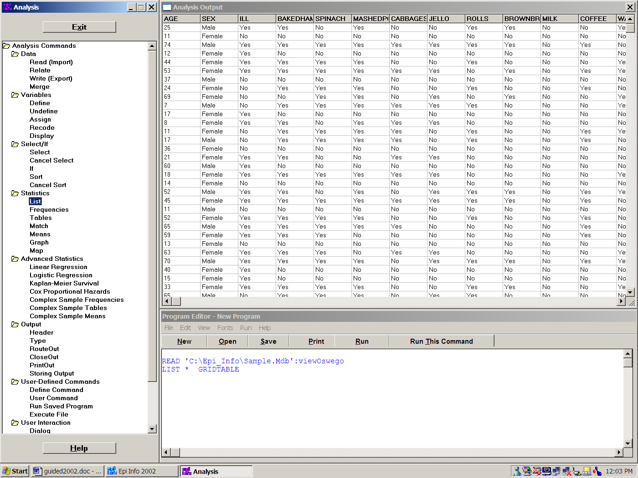
Try the LIST command again, but choose HTML as the output format. This time the results appear in the form of an Internet web page in the Output windows.

Frequencies
Choose the FREQuencies command. In the dialog box, use the dropdown menu to select one or more variables, and then click OK. After a short wait, the results should appear in the browser window. Scroll up and down and note that each table is accompanied by yellow bars to the right that indicate the frequencies. Statistics will be displayed below the table if the value of the variable is numeric, as in AGE, but not for Yes/No fields like ILL.
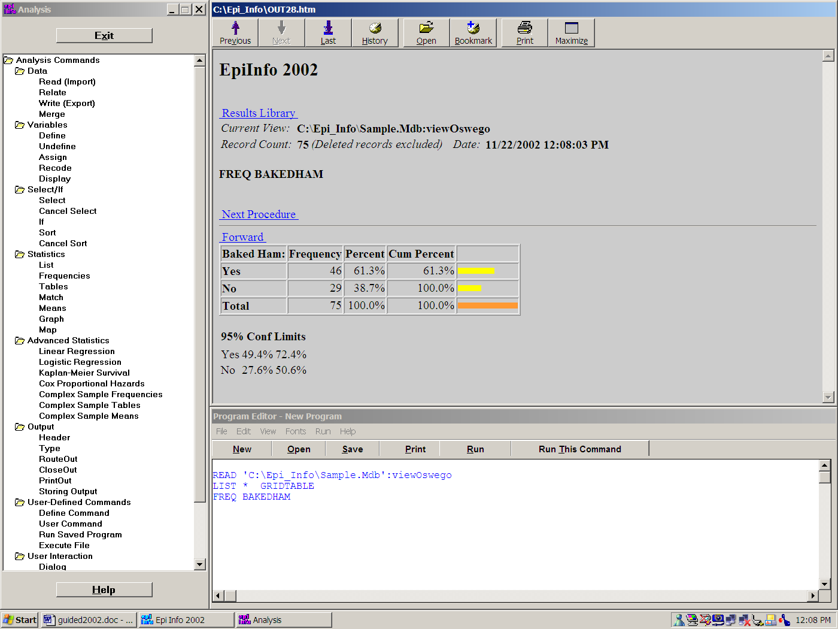

Tables
Click the TABLES command. In the EXPOSURE VARIABLE field, choose VANILLA and for the OUTCOME VARIABLE, choose ILL. This will perform a cross-tabulation of VANILLA by ILL. Note that stratified analyses can be done by inserting the name of the stratifying variable(s). Summary data can be processed by setting WEIGHT equal to the name of a COUNT field. Click OK.

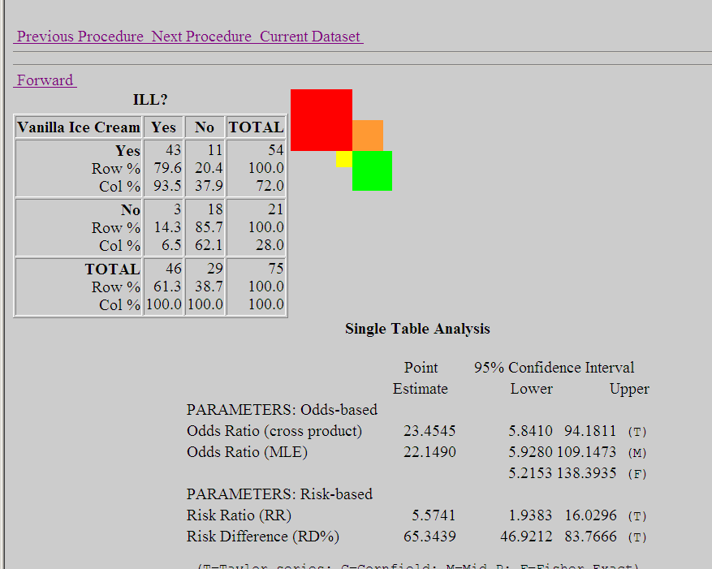
Note that the output in the browser includes a table and a graphic representation of the table values in each cell. Statistics are displayed below the table. If you have a printer connected, try printing the table by clicking on the PRINTOUT command and then OK without entering a file name. Information on the statistics in Epi Info is available in the Statistics section under HELP on the main menu.
Concept | Statistics in Analysis are produced in response to simple commands like Tables and Means. Tables yields the Odds Ratio with several kinds of confidence limits, 3 chi squares, and the Fisher exact test, as well as the Mantel Haenzel summary statistics for stratified tables. Means provides the 1-way Anova, student t, and Kruskal-Wallis tests.

Logistic Regression
Click on Logistic Regression and fill in values as follows:
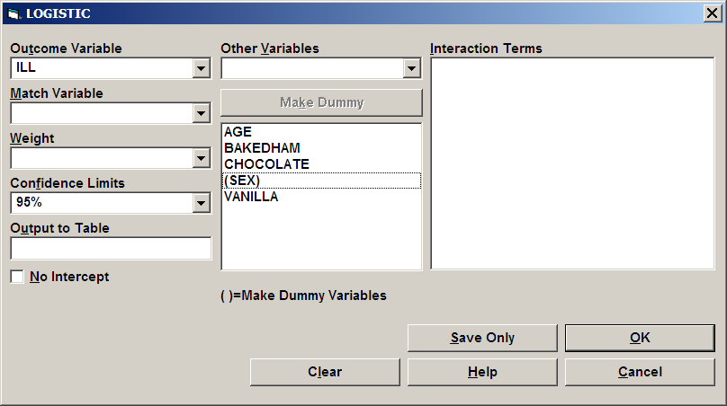
Click OK and study the results, paying particular attention to the Odds Ratios and p values. Again Vanilla ice cream comes to the fore.

Graphing
Epi Info can graph more than one variable at a time and also place more than one graph on a page. To illustrate this, choose the GRAPH command and enter the following values (the title is optional):
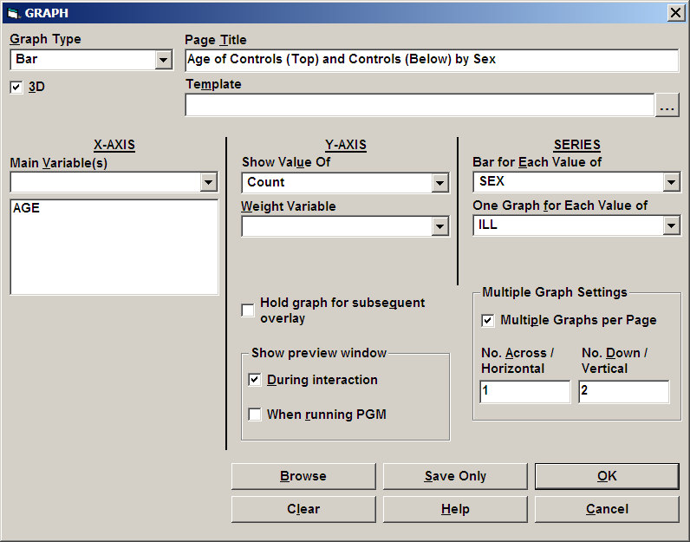
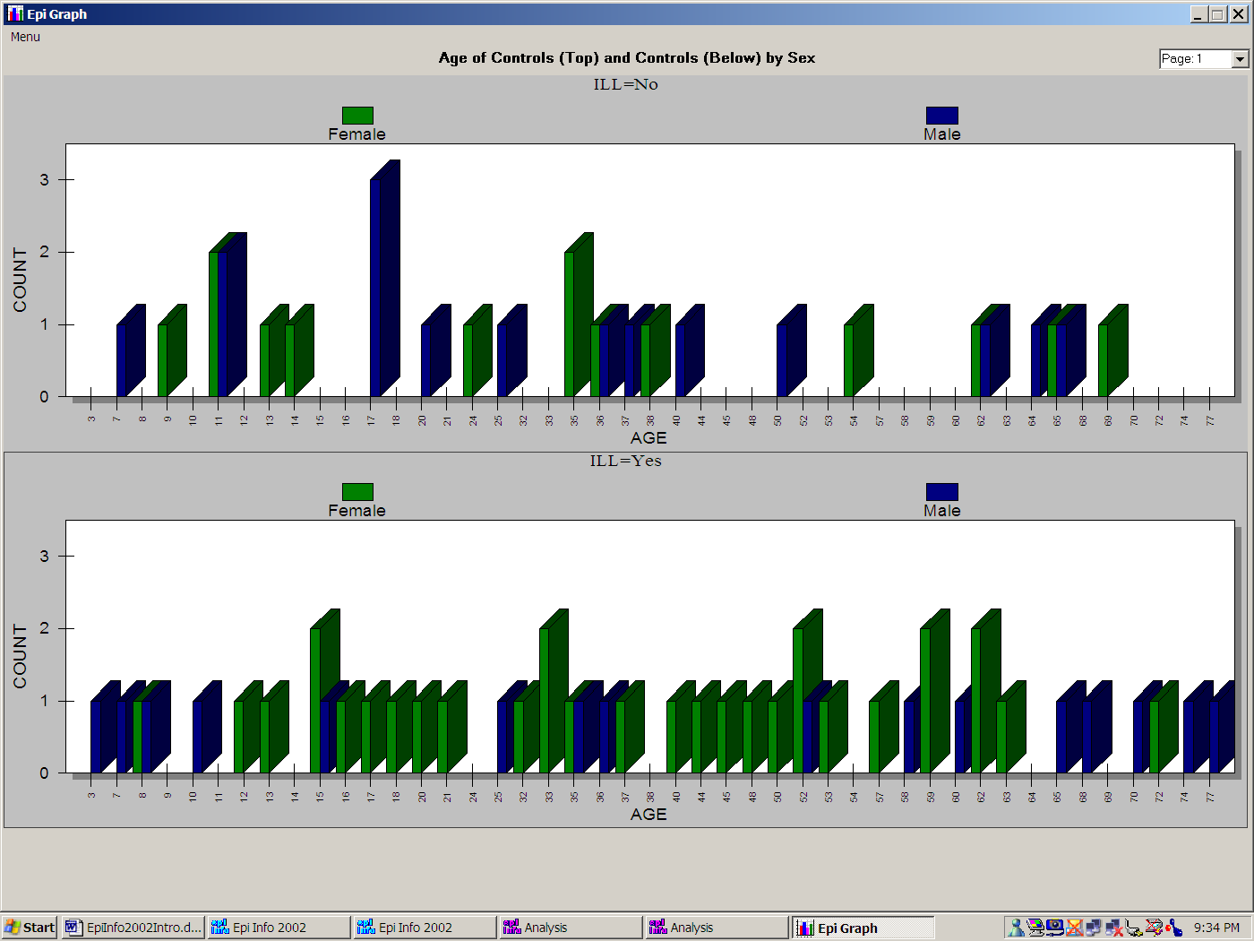

Note that we chose 3D and grouped bars to show off the capabilities of the GRAPH command, but that four separate graphs might have been clearer, and epidemiologists who care more about numbers than entertainment may advise against 3-dimensional graphs.

Viewing Previous Results
Click on CLOSEOUT to close the document you just created and then, click on the hyperlink called RESULTS LIBRARY at the top or bottom of the TABLES output in the browser. An index page appears, showing previous commands that have produced output files. Click on any of the entries to display it. An archiving system is provided so that important results can be selected and saved for future reference. You can learn more about storage of results by choosing the OUTPUT tab and examining the choices under STORING OUTPUT.

Setting the Displayed Values for Yes/No Fields
Click on SET under OPTIONS in the command tree on the left side of the screen. Note the options for customizing output. Change the values to be displayed for Yes/No fields, choosing from those available or typing your own, such as “Si” and “No” in Spanish. Choose LIST again from the STATISTICS tab and verify that the values displayed are those of your choice.
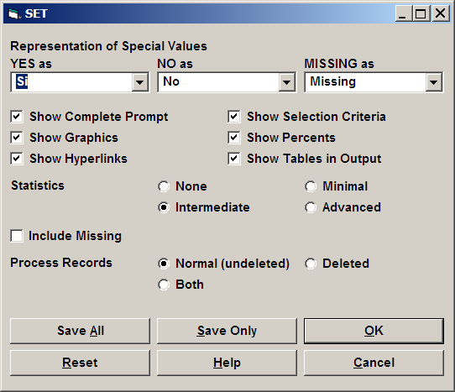

Defining a New Variable
Under Variables, choose the DEFINE command. Type STATUS as the name of a new variable. We want to set this variable to “Case” if the person was ILL and “Control” otherwise. A Standard variable, with the value reset for each record as the program passes through a table, is the best choice for this purpose. Click OK, and the necessary statement will appear in the program editor.
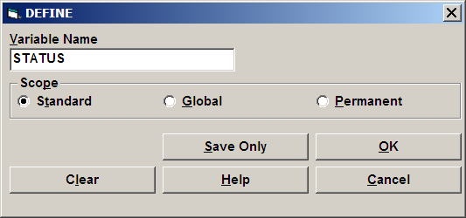

An IF Statement
We can use an IF statement to set the value of the new STATUS variable. Choose the SELECT/IF tab and click on IF. The first item in the dialog is the condition under which the following statements should or should not be executed. The final format of the necessary IF statement is:
IF ILL = (+) THEN
STATUS = "CASE"
ELSE
STATUS = "CONTROL"
END
You will not have to remember the format, however, since filling in the blanks in the dialog will allow Epi Info to write the necessary command in the program editor. In the first blank, fill in the Condition as ILL=(+). To do so, you can choose the variable ILL from the list of variables in the second window and choose the equal sign and condition “Yes” (or “Si”) by clicking on buttons with these labels. The button will display whatever label is specified for “Yes” in the SET dialog— “Yes”, “Si”, etc., but will convert the statement to the international symbol (+).
Regardless of the setting for Yes/No fields, “Yes” is always represented in the database as 1, No as 0, and Unknown as a blank or null value. These values can also be used, as in:

IF ILL = 1 THEN (Note that numbers do not have quotation marks)
Etc.
If you are familiar with commands in Epi Info 6, you can type your own command in the box located under the then button. On the other hand, if you are experimenting for the first time with programming languages, you may want to use the aid available for IF statements. In the first case type STATUS="CASE" in the THEN box and STATUS="CONTROL" in the ELSE box.. Click OK to finish the command.
You can also click the THEN button to gain access to the command tree and insert one or several commands.
When the IF statement is completed, click on the OK button. The complete IFstatement will appear in the program editor.
Use the LIST command to verify that STATUS is indeed properly set, and that records where ILL = “Yes” have “CASE” as the value of STATUS.

The SELECT Command
The SELECT statement limits subsequent analysis to particular records based on criteria that you specify. To work with cases only, for example, choose the SELECT statement and enter the condition STATUS = "CASE".
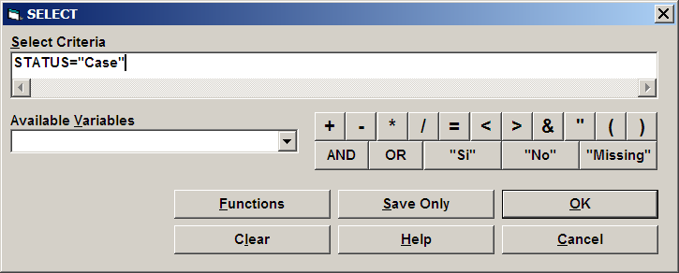
Use LIST or FREQ STATUS to show that cases only are included in the analysis.
To return to working with all the records, choose CANCEL SELECT and note that it places the word SELECT, without conditions, in the program.

The RECODE Command
To Group the values of AGE, first DEFINE a new variable called AGEGROUP, using the DEFINE command. Then Choose RECODE and specify that you will recode from AGE to AGEGROUP, using the drop down list. Click the FILE RANGES button and enter the range 0 for START and 80 for END, with 10 for BY. Click OK, and then do a FREQuency of AGEGROUP to see the results.
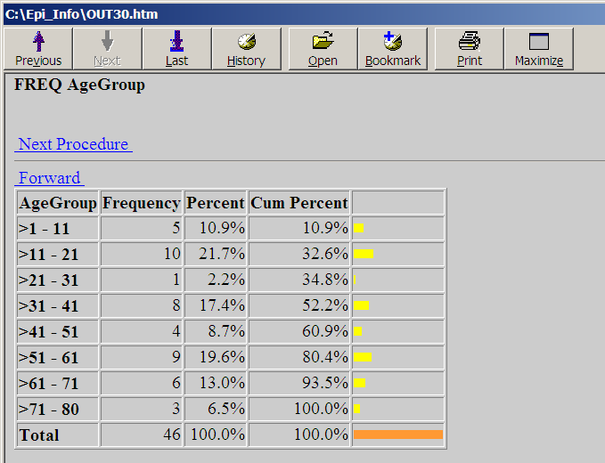

Creating a New File with the WRITE Command
At this point, we have made several improvements in the dataset, and might want to create a file containing the new variables. The new file can be either an Epi Info (Microsoft Access) file or one of many other file types. Choose the WRITE command, and then, from the list of Output Formats, choose “dBASE IV”. Specify “All” variables and “Replace” so that an existing file by the same name will be overwritten. Give your Initials for the file name. Click on OK to write the file.
Concept | A program in Analysis is the collection of commands in the program editor that are generated by interaction with the command tree and dialog boxes. You can edit or type the commands yourself if you are familiar with the syntax. Programs can be saved, retrieved, and run again in Analysis, or invoked from a menu (MNU) file.

Saving a Program (PGM)
To save the current program, click the SAVE button in the program editor (not in the command tree). In the dialog that appears, give a name for your program, such as your own initials, and click OK. Now delete the program from the program editor by clicking the NEW button in the editor. Retrieve the program by clicking on OPEN in the program editor and choosing the program name from the dropdown list. The editor will reload the program, ready to edit or run. By default, programs are saved in the current project or MDB, but, if you prefer, you can save or retrieve text file versions using the TEXT FILE button in the save dialog. By constructing an Epi Info menu to run an Analysis program (PGM) automatically, you can construct a convenient and permanent application to be used again repeatedly and execute any of the actions of which Analysis is capable.
READing a dBASE File
Now that you have produced a dBASE IV file, it is time to test the flexibility of Analysis in READing a variety of file types. Choose READ from the DATA tab, specify dBASE IV format, and read the .DBF file you have just produced. Use LIST and/or FREQ to verify that the variables you created and their values are contained in the new file.

Epi Map | 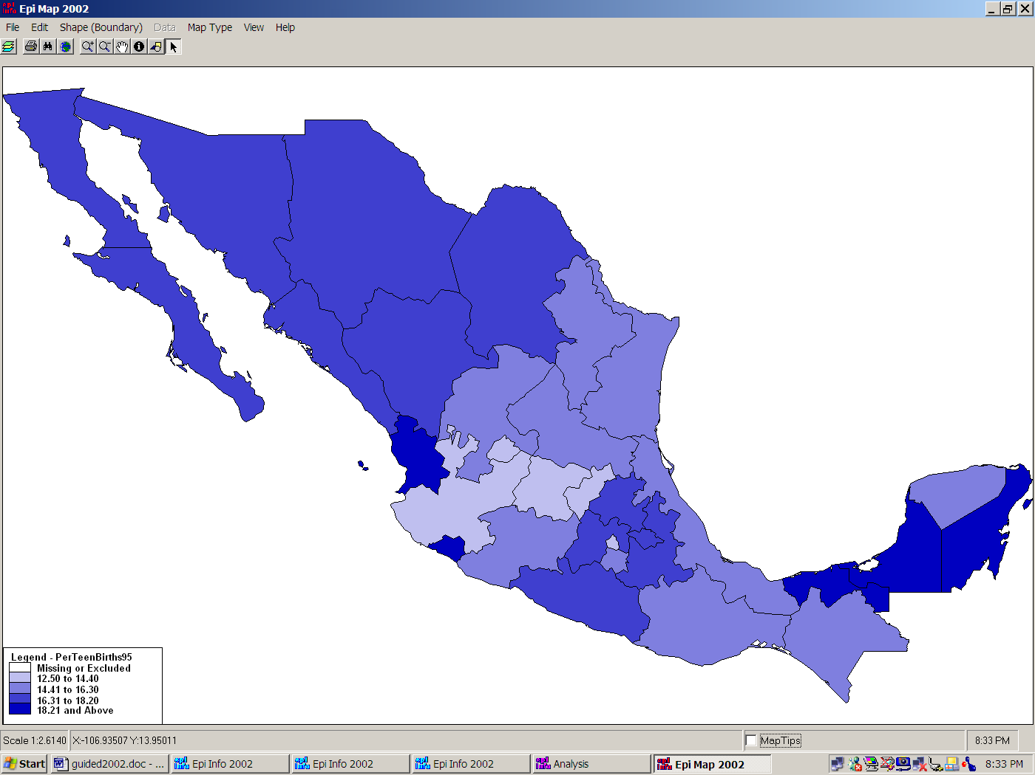

Adding a Shapefile to create a map
Concept | Shapefiles are an industry standard for Geographic Information Systems (GIS) used in the popular ArcView and ArcInfo programs. Shapefiles of every country in the world can be downloaded from the Epi Info website under “Maps”, and the Internet provides thousands of such files. Shapefiles can be drawn or edited in either ArcView or Epi Info for emergency or custom purposes.
First, let’s make a map of Mexico representing one numeric result for each State by coloring the polygons that represent the States. Run Epi Map from the main menu. In the FILE menu of Epi Map choose MAP MANAGER, and from the LAYERS card, click on ADD MAP LAYER. You should see a choice of SHAPE (.SHP) files, containing the boundaries of geographic regions. Open the one called MxState.shp and choose NAME as the field containing the names of Mexico's states.

Adding data to be represented by color density
A database containing public health data from Mexico is provided. Open the SAMPLE.MDB database and choose the table called MexMap95. The appropriate Geographic Field is STATE and the data field is PerTeenBirth95, the percentage of births in which the mother was an adolescent in 1995. You should see a map of Mexico with the adolescent pregnancy percentage for each state represented as a shade of gray.
You can experiment with features such as FIND on the EDIT menu (also represented by the binocular button). Try finding “Vera,” for example. The magnifying glasses with + and - signs are for zooming to larger or smaller sizes. Click on the one with the + sign and then click and drag a rectangle over an interesting part of the map. It will zoom to fill the frame. Try panning—moving the map with the white mitten. You can restore things to normal either with the negative magnifying glass or with the world button that represents the global or home view. The “I” symbol means “information.” Click it and then click on a state to see the data values for that state—both those contained in the Shapefile and those in the linked database.

Creating a map of cholera cases in John Snow's London using X and Y coordinates of case households
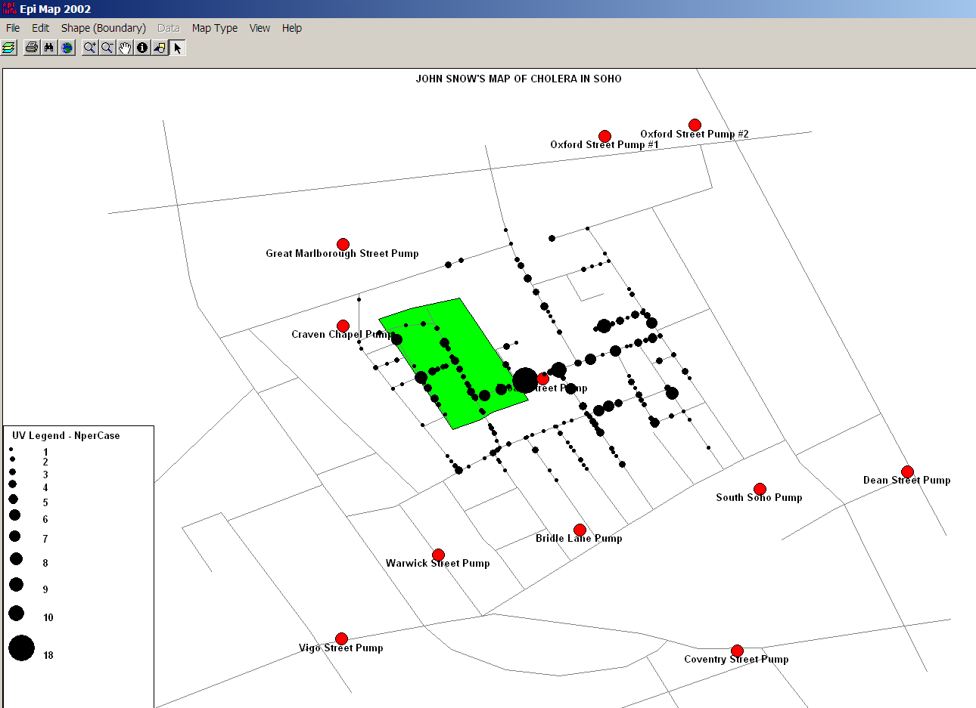
Epi Map can represent data as discrete points on the screen, as well as quantitative values within polygons. The following set of instructions will produce a map resembling John Snow’s famous map of cholera cases in the Soho district of London in relation to the various public pumps used for drinking water. A popular theory of the time related cases to the presence of an old cemetery where plague victims from a previous century had been buried; hence the cemetery will be included as a separate layer in the map.
First run Epi Map from the main menu. From the FILE menu, choose MAP MANAGER. Choose ADD MAP LAYER, and then open the SOHOST.SHP file. SHP stands for SHAPE, the most common type of file used in mapping with Epi Map. Now you should see a map of the streets of Soho. From the map manager and add the cemetery by using ADD MAP LAYER and choosing SOHOBURI.SHP. To add the locations of the water pumps, use ADD POINTS and select SAMPLE.MDB and then SOHOPUMP. Another dialog asks for the x and y coordinate fields. This is an easy choice in this exercise; X Coord is the X coordinate and Y Coord is the Y coordinate. Click on NAME in the choice in the lower left so that the names of the pumps will be displayed. To make the pumps larger, choose 15 for their size, and change the color by clicking in the black rectangle and choosing a brighter color. Click OK after choosing the color, and then again for the dialog. You should see the pumps and their names arrayed on the map.
To display the cases, repeat the ADD POINTS process, this time choosing SOHODEAD from SAMPLE.MDB and 5 for the size of the symbols. Use a contrasting color and do not choose a field for displaying text. Place a checkmark in the box beside SAVE POINTS AS NEW LAYER and another checkmark beside VARY SYMBOL SIZE FOR COINCIDENT POINTS. This is a new feature in Epi Map 2002, that allows the representation of more than one case per household. Click OK and be prepared for a short wait, as the 500 + cases need to be updated many times.

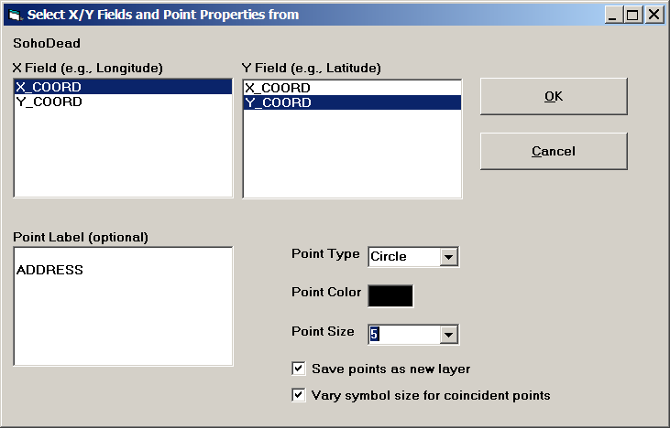You should see points representing the addresses where cases occurred. One household had 18 cases and is represented by the largest dot.
To see the same map without the varying symbol size, put away the Map Manager and choose from the FILE menu, OPEN MAP FILE. Find JOHNSNOW.Map and open it. This view uses the same data, but since the point do not vary in size, the multiple-case households cannot be distinguished from single-case households. The visible points actually represent households having “at least one case” rather than cases individually.
Although the map suggests that the Broad Street pump was central to the location of cases, and other evidence did incriminate this pump, one must remember that the distribution of dots is a function not only of the mortality rate but also of population distribution, and that rates rather than numbers of cases would be necessary to draw a scientific conclusion. Assuming, however, that the population was fairly evenly distributed through Soho, the impression that the map gives is useful. Dr. Snow’s similar map helped him convince the neighborhood council to remove the handle of the Broad Street pump, and the epidemic subsided.
Note that the elements of a map and its linkage to a data table can be saved in a .MAP file and later recalled with a single click. We have demonstrated the linking process from within Epi Map, but it is also possible in Analysis to READ a data set containing geographic names and link it to a shapefile containing polygons of the same names to produce a map. If you have time, READ the data set MEXMAP95 in Sample.MDB and then enter the following values into the MAP dialog in Analysis:
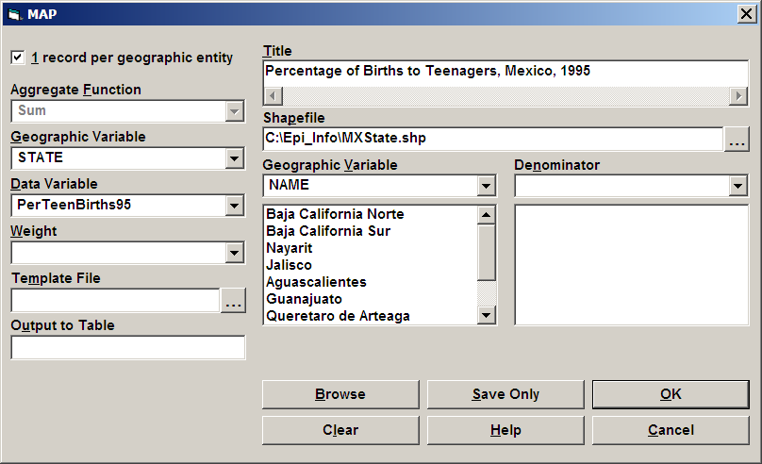

Nutritional Anthropometry with NutStat | 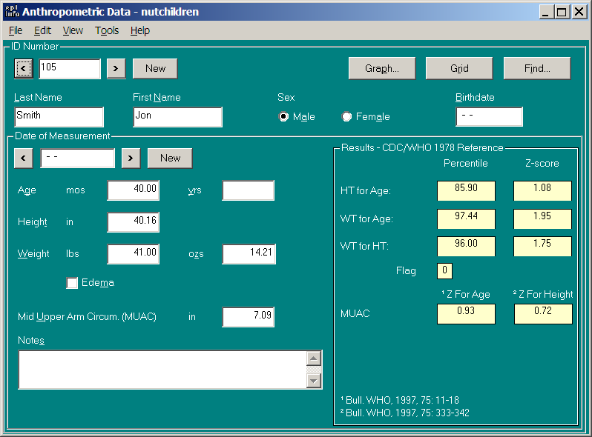

Entering data from one child's measurements
Run the NutStat program by clicking the NUTRITION button on the main menu. The program should obtain the name of the last database accessed from the EPIINFO.INI file and load this database automatically. If you do not see record number 106 and the data table name NUTCHILDREN at the top of the program, use the OPEN command on the FILE menu to open first the NUTRI.MDB database and then the table called NUTCHILDREN.
Click the left arrow next to the IdNumber several times until you see a record belonging to Alouetta Delia. Alouetta has four records in the table. To see the others, click on the left-pointing arrow in the DATE OF MEASUREMENT box and look at each of the earlier records. Click on the GRAPH button. Choose “Z-Scores” as the graph type and click OK to see a graph of her results compared with the International growth reference curves. Age is shown across the bottom of the graph and the left axis shows by how many standard deviations the child's measurement differs from the International average reference standard for that age and sex. The advantage of z-scores (standard deviations) is that both height and weight can be plotted on the same graph. In interpreting the graph, it is important to know that two standard deviations in either direction from 0 is approximately the 95th percentile and three is near the 99th percentile. Hence, in Alouetta's second set of measurements, her height is nearly at the 99th percentile for girls her age, but her weight is slightly below the norm; she must have been tall and slender at age 4 (48 months) when this set of measurements was taken.
To move to another child’s record, choose the next IDNumber by clicking on the right arrow in the IDNumber box. By clicking repeatedly, you will discover how many children there are in this database. Click on the second button to the right of the IDNumber to create a new record and IDNumber Note that clicking the left arrow from the new record will return to the last completed record in the table.
In the new record, enter a name, sex, and birth date. Note that the age is calculated automatically after you press Enter. Now enter values for height and weight (for a 10-year old, 140 centimeters and 40 kilos will do). Note that the statistical calculations appear as soon as you press Enter in the weight field. The body mass index is calculated automatically (but we are awaiting new standards before calculating the age-specific values for body mass index).
Enter 15 centimeters or 6 inches for arm circumference and note the z-scores. Now click on New in the IDNumber box to save the record and go on to the next.
From the File menu, choose Customize to see the options available. On the Units tab, choose either the English or Metric system of measurement, click on Arm Circumference to deselect it, and then choose OK. Note that the main screen now displays only the measurement units selected and that Arm Circumference no longer appears. Return to Customize and set up the main screen in the configuration you find most useful for your own environment.
NutStat offers a choice of the CDC/WHO international growth reference curves of 1978 or, for the United States, the year 2000 CDC growth reference curves. To make this choice click OPTIONS on the TOOLS menu and then choose CDC/WHO 1978 or CDC 2000 growth curves from the tabbed dialog.
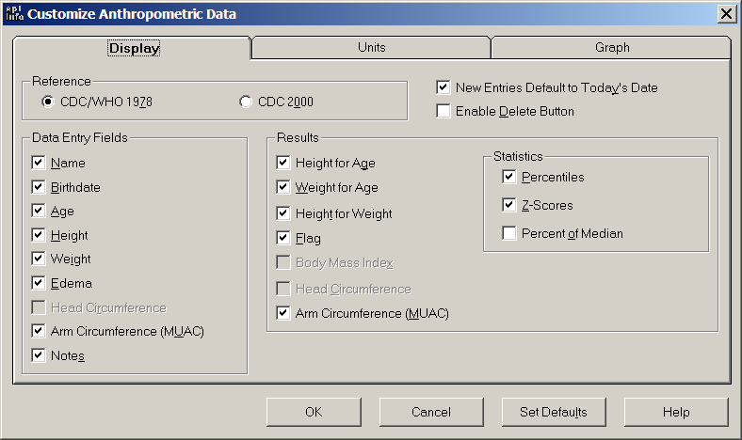

Seeing Inside Databases with VisData | 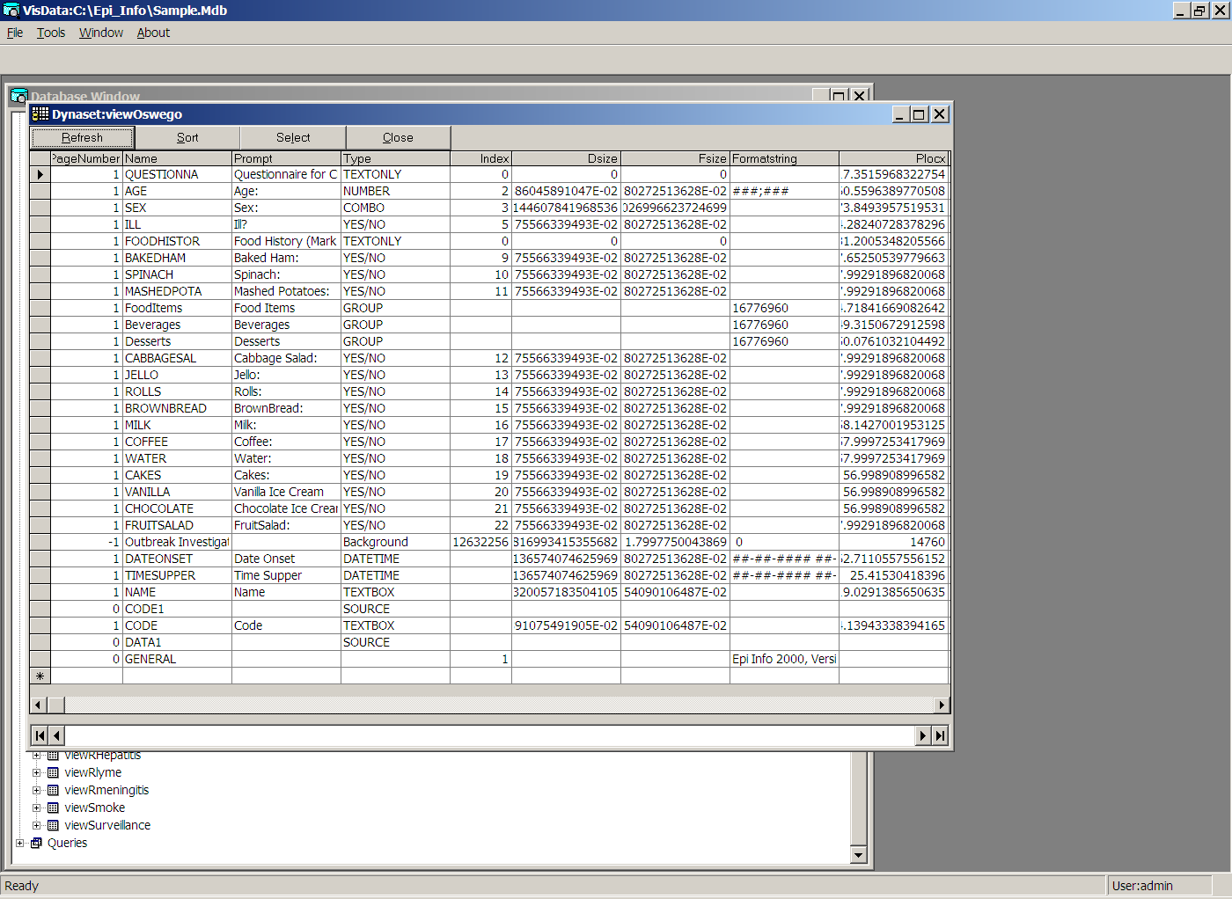

Seeing Inside Epi Info Tables
VisData is a utility program for viewing and performing useful operations on database files or tables. Choose Visualize Data from the UTILITIES menu. Choose OPEN EPIINFO PROJECT from the FILE menu and then the SAMPLE.MDB database. You should see a tree that contains Properties, Tables, and Queries. Click the plus sign next to Tables to see all the tables contained in SAMPLE.MDB. To see the contents of a table, double-click on its icon to display a grid view of the data.
Explore the contents of a code table, the Oswego data table, and viewOswego, a questionnaire View table. Note that the View has a special format that is unique to EpiInfo, but that the data table consists of simple rows and columns with variable names compatible with Microsoft Access and other database programs.
VisData is a useful utility for seeing the internal details of databases. Microsoft Access, if you have it, can be used for the same purpose.

Comparing Data Tables to Validate Data Entry | 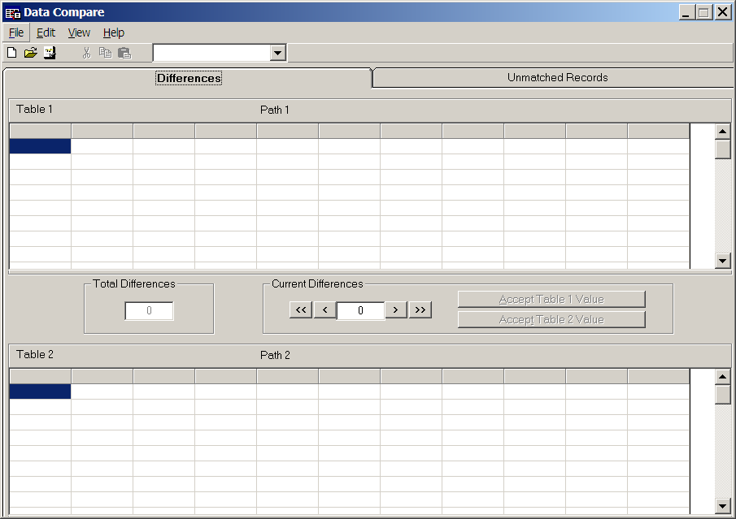

To reach the TableDiff program for comparing two Epi Info data sets or Views, choose Data Compare from the UTILITIES menu. The program that appears is designed to compare two data tables entered by different people from the same set of paper documents. This method is often used for quality control in data entry shops, such as those supporting epidemiologic surveys.

To try out the program, you would first make a copy of the SAMPLE.MDB database, then edit the data in a few records in the Oswego View using Enter. Using the FILE menu in TableDiff to make a NEW script, you would choose the Oswego views in the two MDBs. The key to identify records (in case they are not entered in the same order) should be CODE. Differences in the tables will appear in the top and bottom so that you can make corrections until the two tables are identical or edit the one to be kept. Further details are given in the Help file.

File Encryption and Compression with EpiLock | 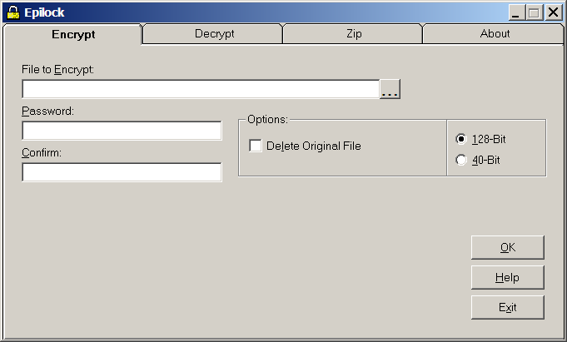

Encryption scrambles data so that it cannot be recovered without the correct password. It is useful to protect sensitive data being sent over the Internet or by email, and also to protect data on a local computer or laptop if it is stolen or otherwise accessed improperly. Zipping or compression reduces the size of data files (sometimes up to 20-fold for MDBs), and is done automatically during encryption or can be selected without encryption. As with any good security procedure, a lost password is the same as lost data; hence be sure to keep a properly secured record of the password or backup copy of the data for any file encrypted with the instruction DELETE ORIGINAL FILE.
To try out EpiLock, study the Help file and then practice encrypting and decrypting a non essential file.

Next Steps
This completes the Guided Tour. You are now familiar with the main features of Epi Info. We suggest that you try working with your own data, either by designing a View and then entering data or by READing an existing dataset in the Analysis program. The Help files provide more detail on the programs, and the How To chapters sections have instructions for solving specific problems. Reference material is in the Commands chapter and is also available from the programs via the Help buttons in particular dialogs.
We hope that you have enjoyed the Tour, and will send your impressions and suggestions to the Development Team at the contact addresses in the front of the manual. If you would like to participate in the Epi Info Worldwide Discussion Group (a LISTSERV) by e-mail, please use the instructions in the front of the manual to join. The Epi Info Web Site is available at all times to provide information, updates of programs, and access to vendors, trainers, and the Epi Info Technical Support staff.

Epi Info Programming in Brief. See the HELP File for Details
Check Code in Makeview and Enter | Analysis (PGM) Programs | Functions and Operators | Menu (MNU) Programs
ALWAYS / END (run check code all the time)  AUTOSEARCH  ASSIGN  CLEAR  DEFINE  DEFINE DLL OBJECT  DIALOG  ENDBEFORE  EXECUTE  GOTO  HIDE  HELP  IF THEN ELSE  RECORDCOUNT  UNHIDE  Field Properties  CODES  COMMENT LEGAL  LEGAL  MUSTENTER  RANGE  REPEAT  REQUIRED  SOUNDEX  RELATE | Variables  RELATE  Data  READ (IMPORT)  RELATE  WRITE (EXPORT)  MERGE  Variable  DEFINE  UNDEFINE  ASSIGN  RECODE  DISPLAY  Select/If  SELECT  CANCEL SELECT  IF  SORT  CANCEL SORT  Statistics  LIST  FREQUENCIES  TABLES  MATCH  MEANS ‌ SUMMARIZE  GRAPH  MAP  Advanced Statistics  LINEAR REGRESSION  LOGISTIC REGRESSION  KAPLAN--MEIER SURVIVAL  COX PROPORTIONAL HAZARDS  COMPLEX SAMPLE FREQUENCIES  COMPLEX SAMPLE TABLES  COMPLEX SAMPLE MEANS  Output  TYPE  ROUTEOUT  CLOSEOUT  PRINTOUT REPORTS  STORING OUTPUT  User-Defined Commands  DEFINE COMMAND  USER COMMAND  RUN SAVED PROGRAM  EXECUTE FILE  User Interaction  DIALOG  BEEP  HELP  QUIT PROGRAM  Options  SET | Operators  (+ - * / ^ MOD)  Comparison  (> >= = <> < <= LIKE)  Booleans  (AND OR XOR NOT)  Numeric  EXP  SIN, COS, TAN  LOG  LN  ABS  RND  TRUNC  ROUND  NUMTODATE  NUMTOTIME  Text Functions  TXTTONUM  TXTTODATE  SUBSTRING  UPPERCASE  FINDTEXT  FORMAT  Date Functions  YEARS  MONTHS  DAYS  YEAR  MONTH  DAY  Time Functions  HOURS  MINUTES  SECONDS  HOUR  MINUTE  SECOND  System Functions  SYSTEMDATE  SYSTEMTIME  ENVIRON  EXISTS | Commands  ASSIGN  BROWSER  BROWSERSIZE  BUTTON  CALL  DEFINE  DIALOG/MESSAGE  EXECUTE/RUN/LINKTO/ACTIVATE  EXIT  FILEDIALOG  GETPATH  HELP  IF THEN ELSE  LINK  LINKREMOVE  MENU  MENUITEM  MOVEBUTTONS  PICTURE  PICTURESIZE  REPEAT UNTIL  REPLACE  SCREENTEXT  SETBUTTONS  SETDBVERSION  SETDOSWIN  SETINIDIR  SETLANGUAGE  SETPICTURE  SETWORKDIR  SYSINFO  UNDEFINE  WAITFOR  WAITFOREXIT  WAITFORFILEXISTS  Special Command Block Names  SHUTDOWN  STARTUP  Functions  EXISTS  System Variables  COMPDATE  INIDIR  INSTALLDIR  MENUDIR  SYSTEMDATE  WORKDIR  Value of Variable  @@

Revised and updated for Epi Info 3.4. Based on the Guided Tour of Epi Info distributed by the Centers for Disease Control and Prevention (CDC) and written by the author while at CDC. The text and pictures may be freely copied, translated, and distributed.

